**UNIVAL PROFILE**

**Page 1 photo :**

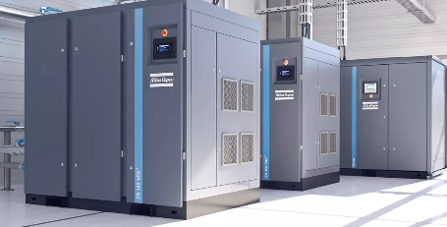

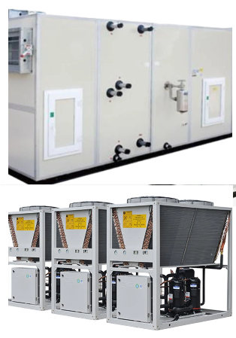

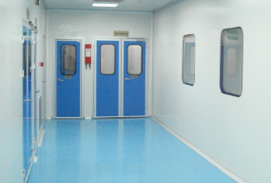

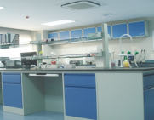

1. **Why Us?**

At Unival, we are passionate about advancing the pharmaceutical industry through innovation and expertise. Founded in 2021, our team of dedicated professionals specializes in providing comprehensive consulting services, sourcing high-quality medical and pharmaceutical supplies, and designing projects that comply with international standards.

We pride ourselves on our customer-centric approach, working closely with our clients to deliver tailored solutions that drive success. Whether you're looking for expert guidance or reliable products, we are here to support your goals and enhance your operational efficiency.

- Integrity: We operate with honesty and transparency, ensuring that our clients can trust our services and solutions.

- Quality: We are committed to delivering the highest quality in all our services and products, adhering to international standards.

- Innovation: We embrace creativity and innovation, continually seeking new ways to improve and adapt to industry changes.

- Customer-Centric Approach: Our clients are at the heart of everything we do. We listen to their needs and tailor our services to meet their expectations.

- Collaboration: We believe in the power of teamwork and collaboration, both within our team and with our clients,.**to achieve shared goals.**

**Page 2 photo**



1. **Business Strategy & Foundation :**

**B1- Business Scope:**

At Unival, our expertise spans a wide range of services tailored to meet the diverse needs of various industrial sectors. Our scope includes suppling the following :

**Consultation:** Our expert consultants offer tailored advice to help you navigate challenges and optimize your operations for better efficiency and effectiveness.

**Project Management**: We specialize in managing projects from inception to completion, ensuring timely delivery and adherence to budgetary constraints while meeting client specifications.

**Cleanroom System Calibration**: We offer calibration services for cleanroom systems, including facilities, utilities, machines, equipment, and instruments, to maintain operational integrity and compliance.

 تغيير الsymbol

**Trading of Machineries, Equipment, Instruments & Tools**: We supply a comprehensive range of machinery and tools suitable for all industrial applications, ensuring top quality and performance

**Validation and Qualification:** Our validation and qualification services ensure that systems and processes meet regulatory requirements and industry best practices.

**Raw & Packaging Material:** We provide high-quality raw materials and packaging solutions to support your production processes and ensure compliance with industry standards.

**Maintenance and Sanitization**: We provide comprehensive maintenance and sanitization services to keep equipment and facilities operating at peak performance and in adherence to hygiene standards.

**B2- Products, Services, and Business Partnership**

1. **Professional GMP Design**

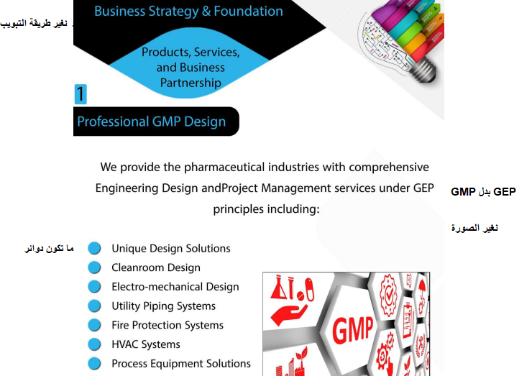

We provide the pharmaceutical industries with comprehensive Engineering Design and Project Management services under GMP principles including:

1. Unique Design Solutions
2. Cleanroom Design
3. Electro-mechanical Design
4. Utility Piping Systems
5. Fire Protection Systems
6. HVAC Systems
7. Process Equipment Solutions
8. Packaging Equipment
9. Packaging Materials
10. **Pharmaceutical Factory Turnkey Project**

In partnership with Unival China, our company supplies specialized cleanroom solutions, including cleanroom sandwich panel, ceiling systems, cleanroom doors and windows, along with related products. Together, we offer comprehensive support in product development, manufacturing, sales, consulting, and service to meet all cleanroom requirements.

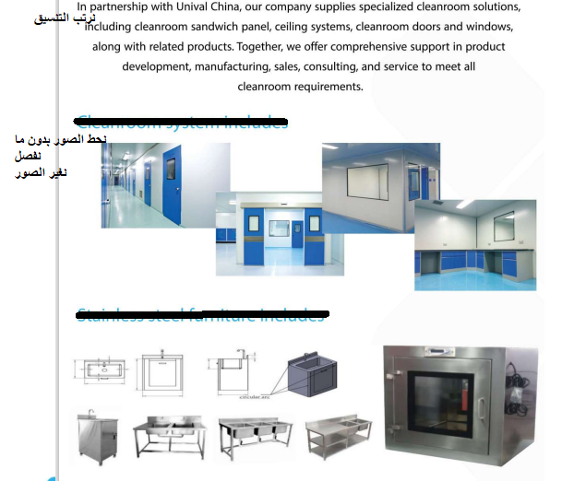

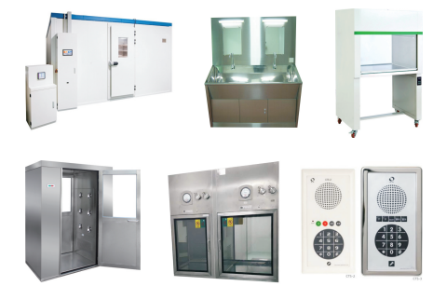

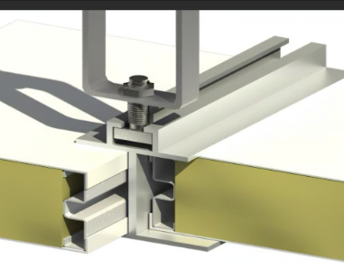

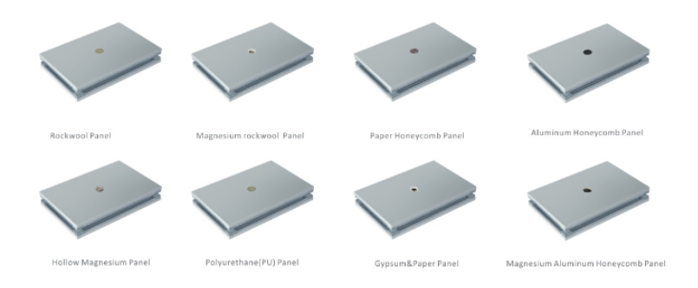

1. **Full documented system depending on confidential protocols**

We provide a comprehensive, fully documented system for the pharmaceutical industry, ensuring strict adherence to confidential protocols and regulatory standards across all phases of production and facility operations. Our services include:

* 1. **User Requirement Specifications (URS):** Custom specifications aligned with client and regulatory requirements
  2. **Protocol Development and Execution:** Tailored qualification protocol writing and execution to meet pharmaceutical standards
  3. **Quality Risk Management**
  4. **Calibration Services**
  5. **Commissioning Plans**
  6. **Temperature Mapping Services**: Accurate environmental monitoring to maintain required storage and production conditions
  7. **Cleanroom Qualification:** Comprehensive cleanroom validation to ensure compliance with GMP standards
  8. **Support pharmaceutical facilities** with:
     + Factory Acceptance Testing (FAT)
     + Site Acceptance Testing (SAT)
     + Complete Qualification and Validation Services, including Design Qualification (DQ), Installation Qualification (IQ), Operational Qualification (OQ), and Performance Qualification (PQ)

1. **Air quality:**

In partnership with Veck (Tianjin) Co. Ltd., We offer a comprehensive range of HVAC systems, to create clean and comfortable environment for our customers including:

* Fan Coil Units
* Ceiling Concealed Air Handling Units
* Heat Recovery Air Handling Units
* Modular Series Air Handling Units
* DX Modular Air Handling Units
* Air-Cooled Ducted Units
* Water-Cooled DX Modular Air Handling Units
* Modular Air-Cooled Chillers (Heat Pumps)

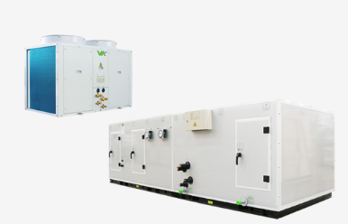

1. **Machineries**

**5.1-** In partnership with **SHINVA Pharmaceutical Technology Group**, we provides the pharmaceutical industry with engineering and design services for sterile injections, solid dosage forms, medicinal products, and biopharmaceuticals. The company also offers comprehensive solutions, individual equipment, and research and technical services for pharmaceutical processes. SHINVA specializes in full solutions for ampoule sterilizers and blow-fill-seal machines, from preparation systems to integrated sterilization solutions.

**5.2** In partnership with **STC**, we provides comprehensive solutions in mixing and granulation (powder pressing and multi-layer tableting technology) for serving pharmaceuticals industries and extend to food, and cosmetic industries

**5.3**In partnership with **Liaoning Tianyi Machinery Co., Ltd**, we are equipped to deliver comprehensive services for the pharmaceutical industry, specializing in the development, manufacturing, sales, and after-sales support of advanced pharmaceutical machinery, including full-automatic hard gelatin capsule filling machines, tablet presses, and PFS plastic capsulation packing machines

**5.4** in partnership with **Xiaolun United**, we can provide the following pharmaceutical machinery and equipment:

Coating Machine Series

Granulator Series

Fluid Bed Dryer (FBD) Series

Lifting Tipper with Mill Series

Lifting Charging Machine Series

Mixing Machine Series

IBC Bin Series

Bin Washer Series

Cone Mill and Hammer Mill Series

Each of these high-quality solutions is designed to meet stringent pharmaceutical standards, supporting efficient and compliant manufacturing processes.

1. **Packaging :**

6.1 provide (PVC) hard sheets for pharmaceutical and food packaging from our partner **Younker Packaging Technology Co., Ltd.** with ensuring the highest domestic standards in the medicinal PVC industry to gain recognition and success in both domestic and international markets.

6.2 provide a full range of high-quality glass packaging solutions from our partner **Changzhou Four Stars Glass Co., LTD**, including:

* **Neutral Glass Tubing**
* **Glass Ampoules**
* **Vial Series**:
  + Injectable Vials
  + Oral Liquid Vials
  + Screw-neck Vials
  + Printed Vials

These products meet stringent industry standards, supporting a variety of pharmaceutical packaging needs.

**B3- Market Coverage**

At Unival, we proudly serve a diverse range of markets across multiple regions. Our business operations extend to:

* We have established a strong presence in middle east catering to the unique needs of industries in this region.
* Our expertise also reaches middle east, where we provide tailored solutions to meet the demands of the local market.
* We actively pursue opportunities in middle east, ensuring that our services align with regional regulations and standards.

MAP:

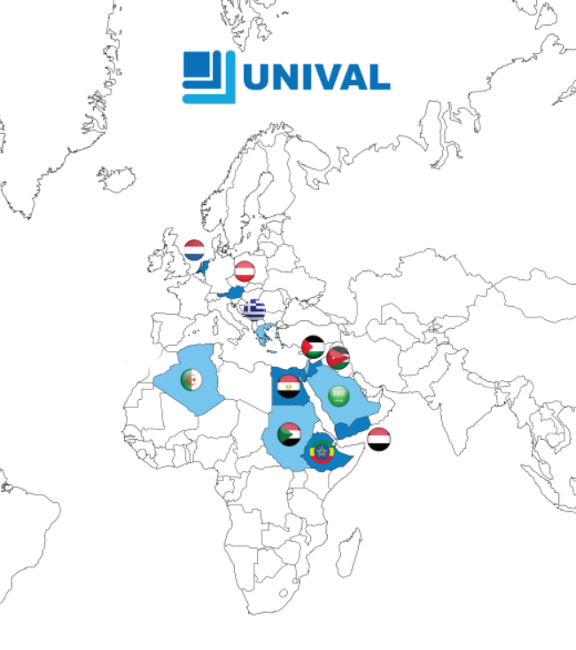

**B4- Business Growth Plan :**

Looking ahead, our business growth plan is strategically aligned with our vision for sustainable development. We aim to expand our market presence through [outline key strategies, such as entering new markets, diversifying product lines, enhancing customer engagement]. Our focus on research and development, coupled with a commitment to operational excellence, positions us to achieve our growth objectives while delivering long-term value to our stakeholders.

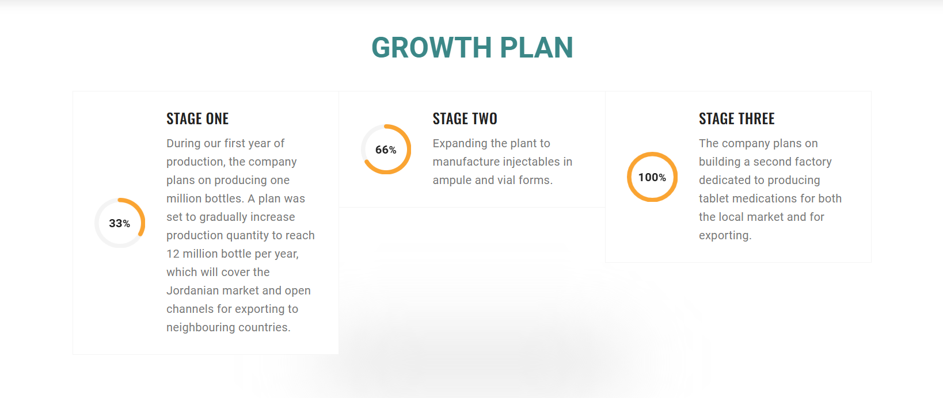

**Stage One**

Focus on providing consultation services and project management specifically for the pharmaceutical industry.

**Stage Two**

Expand our offerings to specialize in supply and execution of turnkey solutions, encompassing all related utilities.

Achieve certification in ISO 9001 and ISO 17025 to conduct testing, commissioning, and qualification processes.

**Stage Three**

Obtain NEBB certification to ensure compliance with rigorous standards and procedures.

Establish ourselves as the exclusive agent for leading pharmaceutical machinery and utility providers.

1. ***Our team***
2. **Mutaz Salman**

Position: Engineering Manager

Education:

* Bachelor’s degree in Chemical Industries Engineering – TTU

Professional Development:

- Specialized training in the design of mechanical engineering systems, including firefighting, HVAC, and plumbing.

- Proficient in AutoCAD Mechanical and Revit for MEP (Mechanical, Electrical, and Plumbing) engineering.

- Extensive knowledge in safety and hazard management in chemical handling.

- Certified Lead Auditor for Occupational Health and Safety Management Systems (OHSMS) ISO 45001.

- Familiar with OHSAS 18001 and ISO 14001 standards.

- Currently a candidate for Project Management Professional (PMP) certification.

Brings over 15 years of extensive experience in industrial engineering. His background encompasses a wide range of projects and responsibilities, allowing him to develop a deep understanding of engineering principles and practices within the industrial sector. This experience equips him with the ability to effectively manage complex engineering tasks, ensure compliance with safety standards, and lead teams towards successful project outcomes.

1. **Marwa Saleem**

General Manager

Education:

- Master of Business Administration (MBA) – Edinburgh Business School, UK

- Bachelor’s Degree in Chemical Industries Engineering –TTU, Jordan

- Certified Project Management Professional (PMP) – Project Management Institute (PMI), USA

- Certified Business Consultant – London Business College

Professional Development:

- ISO 17025:2017 Certification

- KAIZEN Training – Japan International Cooperation Agency (JICA), Japan

Experience:

With 15 years of extensive experience in pharmaceutical engineering, developed a robust expertise in quality assurance and strategic planning. The comprehensive background enables her to effectively lead teams, optimize processes, and drive organizational success within the pharmaceutical sector.

1. **Rasha Abu Naba**

Position: Compliance Manager

Education:

* Bachelor’s degree in Biomedical Engineering – Hashemite University
* Certified Pharmaceutical GMP Professional candidate - American Society for Quality
* Professional Development:
* Completed training in Good Manufacturing Practices (GMP).
* Experience:

Brings 15 years of extensive experience in medical and pharmaceutical technical support. Her expertise in compliance and quality assurance enables her to effectively navigate regulatory requirements and ensure adherence to industry standards.

1. **Noor Al-Najjar**

Position: Supply Chain Manager

Education:

* Agriculture engineering in Balqa’ applied University-Salt
* Certified Supply Chain Export candidate - The International Association for People & Performance Development

Courses:

* Clearance and customs

Experience: with 15 years of experience in Purchasing and Supplies Management.

1. **Ramadan Nofal**

Position: Project Engineer

Education:

* Mechanical Engineering: air conditioning, refrigeration and heating system -TTU

Courses:

* Project Management Professional candidate

1. With 7 years of experience as an electromechanical engineer, wide range of electromechanical systems, enabling him to effectively contribute to project success through innovative solutions and meticulous attention to detail.
2. **Eman Asa’d**

Position: Quality Officer

Education: Chemistry In Al-Albait University

Courses:

* Internal Audit
* Good manufacturing Practices
* ISO 13485
* Lead Auditor iso 9001:2015 candidate

With 5 years of experience in Quality Management Systems (QMS), She has developed a comprehensive understanding of quality assurance processes and regulatory compliance. Her expertise includes the implementation and maintenance of QMS frameworks, conducting audits, and driving continuous improvement initiatives.

1. **Mu Kai**
2. **Quality Culture :**

At Unival, we believe that a strong quality culture is the foundation of our success. Our commitment to quality is embedded in every aspect of our operations and is reflected in our core values:

* ISO 9001:2015 Certified
* ISO 17025:2017 Candidate
* NEBB Candidate
* GEP-Good Engineering Practices
* Good Manufacturing Practices Applied
* Project Management Professional Applied

1. **Our clients**

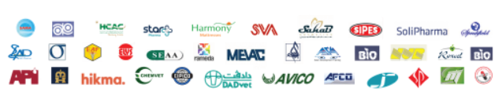

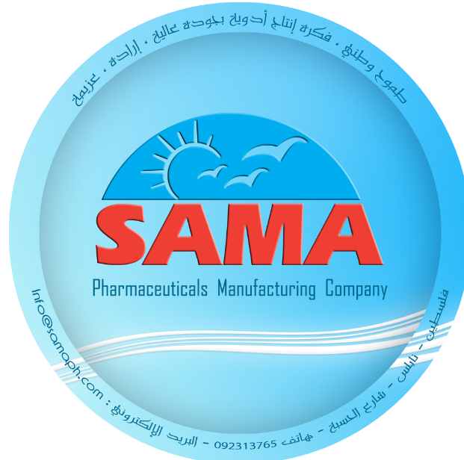 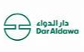

Karnaf Liquid & semisolid KSA

C-Green Semisolid & liquid

Hadeel Clean room

Badael Turnkey project

1. Portfolio:

Our mission is to deliver clean room solutions that meet regulatory standards and ensure optimal environmental control for manufacturing processes. With years of experience and a commitment to innovation, we support the pharmaceutical industry in maintaining the highest standards of cleanliness, safety, and efficiency.

|  |
| --- |
| You can make it as a **project cycle** and below each category add the photo  Like this |

**1- project management, project planning, and feasibility study** 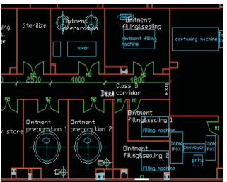

* 1. **Product Supply and installation**

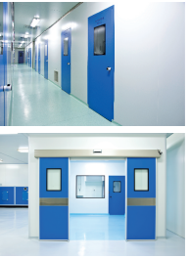

(photo from profile page 10)

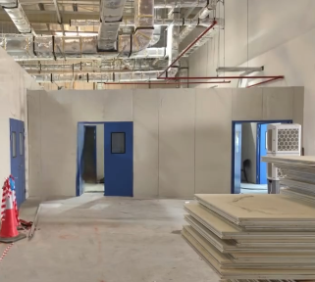

* 1. **utilities( HVAC, Boiler, Chiller ,compressor….)**

**from profile pagr 12**

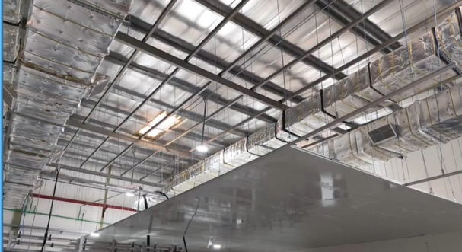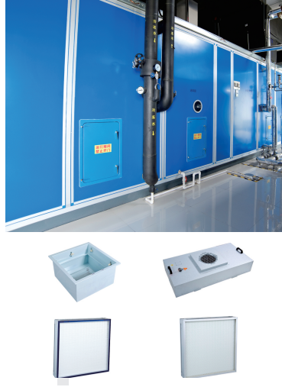

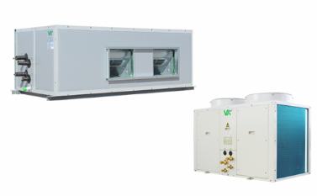 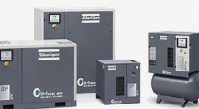

* 1. **Testing , commissioning , and qualification**

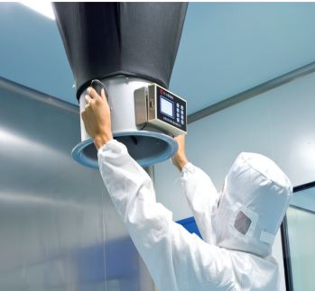 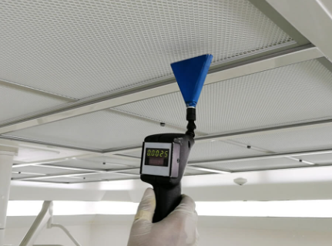 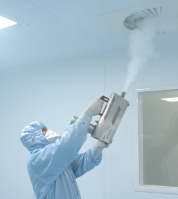

1. Thanks closing –

With Trusted union for industrial consultation as your trusted partner in clean room solutions, you gain an experienced team committed to your success

We are committed to be your partner in success, delivering projects that uphold the highest standards of quality and regulatory compliance. Together, we’ll create a cleaner, safer, and highly efficient manufacturing environment that drives your goals forward.